VIVEKANAND EDUCATION SOCIETY’S INSTITUTE OF TECHNOLOGY
(An Autonomous Institute Affiliated to University of Mumbai
Department of Computer Engineering)

Department of Computer Engineering


Project Report on

CredMill - An AI Credit Risk Assessor

In partial fulfillment of the Fourth Year (Semester–VII), Bachelor of Engineering
(B.E.) Degree in Computer Engineering at the University of Mumbai Academic Year 2025-26

Project Mentor - Dr. Gresha Bhatia
Deputy HOD, Department of Computer Engineering

Submitted by

Gaurav Gupta (D17C-26), Suryanarayan Panigrahy (D17C-47),
Harsh Patil (D17C-50), Hemant Satam (D17C-56)

(2025-26)

VIVEKANAND EDUCATION SOCIETY’S INSTITUTE OF TECHNOLOGY
(An Autonomous Institute Affiliated to University of Mumbai
Department of Computer Engineering)

Department of Computer Engineering


CERTIFICATE of Approval

This is to certify that _Gaurav Gupta (D17C-26), Suryanarayan Panigrahy (D17C-47),
Harsh Patil (D17C-50), Hemant Satam (D17C-56)_of Fourth Year Computer Engineering studying under the University of Mumbai has satisfactorily presented the project on “CredMill - An AI Credit Risk Assessor” as a part of the coursework of PROJECT-I for Semester-VII under the guidance of Dr. (Mrs.) Gresha Bhatia. in the year 2024-2025.
________________
Date

__________________ |  | __________________
Internal Examiner |  | External Examiner

_________________ __________________ __________________
Project Mentor Head of the Department Principal
Dr. Mrs. Nupur Giri Dr. J. M. Nair

ACKNOWLEDGEMENT

We are thankful to our college Vivekanand Education Society’s Institute of Technology for considering our project and extending help at all stages needed during our work of collecting information regarding the project.

It gives us immense pleasure to express our deep and sincere gratitude to Deputy HOD Dr. Gresha Bhatia (Project Guide) for her kind help and valuable advice during the development of project synopsis and for her guidance and suggestions.

We are deeply indebted to Head of the Computer Department Dr.(Mrs.) Nupur Giri and our Principal Dr. (Mrs.) J.M. Nair , for giving us this valuable opportunity to do this project.

We express our hearty thanks to them for their assistance without which it would have been difficult in finishing this project synopsis and project review successfully.

We convey our deep sense of gratitude to all teaching and non-teaching staff for their constant encouragement, support and selfless help throughout the project work. It is great pleasure to acknowledge the help and suggestion, which we received from the Department of Computer Engineering.

We wish to express our profound thanks to all those who helped us in gathering information about the project. Our families too have provided moral support and encouragement several times.

Computer Engineering Department

COURSE OUTCOMES FOR B.E PROJECT

Learners will be to:-

Course Outcome | Description of the Course Outcome
CO 1 | Do literature survey/industrial visit and identify the problem of the selected project topic.
CO2 | Apply basic engineering fundamental in the domain of practical applications FORproblem identification, formulation and solution
CO 3 | Attempt & Design a problem solution in a right approach to complex problems
CO 4 | Cultivate the habit of working in a team
CO 5 | Correlate the theoretical and experimental/simulations results and draw the proper inferences
CO 6 | Demonstrate the knowledge, skills and attitudes of a professional engineer & Prepare report as per the standard guidelines.

Abstract

This project proposes CredMill, a resource-efficient, explainable, and fair AI-driven credit risk assessment system designed for small-to-medium-scale operational environments. Traditional manual credit evaluations are slow, prone to human inconsistency, and often fail to capture complex, nonlinear patterns in borrower data. While AI-based solutions have demonstrated improvements in predictive accuracy, they frequently function as opaque “black boxes,” demand costly computational resources or proprietary APIs, and overlook the need for fairness auditing and bias mitigation. CredMill addresses these limitations by integrating lightweight yet high-performing machine learning models—particularly tree-based ensemble methods—with interpretability frameworks such as SHAP and LIME to ensure transparency at both global and individual decision levels. The system combines traditional credit data with selected alternative data sources, allowing it to model a broader view of borrower creditworthiness without excessive computational overhead. By embedding fairness metrics and mitigation strategies into the workflow, CredMill ensures compliance with ethical and regulatory standards while maintaining strong predictive capability. The final design delivers a practical, low-cost prototype capable of running on modest hardware or free cloud platforms, offering lenders a transparent, adaptable, and equitable tool for credit decision-making.

INDEX
Chapter No. | Title | Page No.
1 | Introduction | 7
1.1 | 1.1. Introduction to the project | 7
1.2 | 1.2. Motivation for the project | 7
1.3 | 1.3. Problem Definition | 8
1.4 | 1.4 Relevance of the Project | 9
1.5 | 1.5 Methodology used | 9
2. | Literature Survey  2.1 Research Papers Referred  2.2 Interactions with Domain Experts  2.3 Patent Search Summary  2.4 Existing Systems  2.5 Lacuna in Existing Systems  2.6 Comparison of Existing Systems and Proposed Work  2.7 Focus Area | 11  11  15  16  17  17  17
3. | Requirement Of Proposed System  3.1 Proposed Model  3.2 Functional Requirements  3.3. Non-Functional Requirements  3.3. Constraints  3.4. Hardware & Software Requirements  3.5. Techniques utilized till date for the proposed system  3.6. Constraints for working | 19  19  19  20  21  21  22
4. | Proposed Design  4.1 Block diagram representation of the proposed system  4.2. Modular diagram representation of the proposed system  4.3 Design of the proposed system with proper explanation:  Flowchart for the proposed system  4.4 Proposed algorithms | 23  23  26  26  27
5. | Proposed Results and Discussions | 31
6. | Plan Of Action For the Next Semester | 36
7. | Conclusion | 37
8. | References | 38
9. | Appendix | 39

Chapter 1: Introduction

1.1 Introduction
Credit risk assessment lies at the core of every lending operation, as it directly influences decisions such as loan approval, credit limit allocation, and interest rate determination. The primary objective of credit risk assessment is to estimate the likelihood of a borrower defaulting on a loan or financial obligation. Traditionally, banks and financial institutions have relied on manual assessments or predefined scoring models such as credit bureau scores. While these approaches have been effective to an extent, they are often time-consuming, subjective, and limited in their ability to handle large-scale and heterogeneous data.
With the rapid advancement of Artificial Intelligence (AI) and Machine Learning (ML), financial institutions have started leveraging data-driven approaches for automating and refining the credit evaluation process. These intelligent systems can identify complex, nonlinear relationships between financial variables, behavioral patterns, and repayment histories, leading to more accurate risk prediction. However, many AI-driven systems operate as “black boxes”, offering little to no transparency in how decisions are made. This lack of interpretability poses significant challenges for compliance, trust, and ethical deployment—particularly in regulated industries like finance.
CredMill aims to bridge this gap by developing an explainable, fair, and computationally efficient credit risk assessment system. The project focuses on providing interpretable decision-making through explainable AI (XAI) methods while ensuring that the model’s predictions remain equitable and resource-friendly. By doing so, it supports responsible and transparent AI usage in financial decision-making environments.

1.2 Motivation
In the modern financial ecosystem, digital lending and AI-based credit scoring have become increasingly prevalent. However, small and medium financial institutions, especially in developing economies, often face barriers to adopting such technologies. Many of the existing AI models demand high-end infrastructure, depend on expensive APIs or cloud services, and fail to incorporate explainability and fairness—two pillars essential for building trust among stakeholders and regulators.
Moreover, as AI systems learn from historical data, they are susceptible to bias and discrimination, especially when the underlying datasets reflect social or economic inequalities. Such biased systems may unintentionally disadvantage specific demographic groups, raising ethical and legal concerns.
The motivation behind CredMill is therefore twofold:
- To democratize access to AI-powered credit scoring tools that can run efficiently on limited hardware and open-source platforms.
- To ensure that credit decisions are explainable, transparent, and fair, promoting accountability and ethical compliance in automated financial systems.
In essence, CredMill seeks to empower smaller lenders and credit institutions to make accurate, fair, and transparent lending decisions without relying on costly or opaque commercial AI products.

1.3 Problem Definition
Traditional credit risk assessment systems suffer from multiple limitations that make them less effective in today’s data-driven world. These include:
- Lack of transparency: Conventional and AI-based models often behave like “black boxes,” providing predictions without clear reasoning.
- High computational requirements: Many AI systems demand powerful hardware and cloud infrastructure, making them impractical for small financial institutions.
- Fairness concerns: Models trained on biased historical data can produce discriminatory outcomes against certain groups.
- Limited data scope: Traditional systems often rely solely on structured financial data, ignoring useful alternative data sources like transaction behavior or social indicators.
Hence, the core problem statement of this project is:
To design and implement a resource-efficient, explainable, and fair AI-based credit risk assessment system that integrates traditional and alternative data sources while remaining practical for small-to-medium-scale environments. This system should provide interpretable model outputs, ensure ethical fairness auditing, and be deployable using affordable, open-source technologies.

1.4 Relevance of the Project
The proposed system is highly relevant to the present-day banking, fintech, and microfinance sectors, which are undergoing digital transformation at an unprecedented rate. As credit decision-making becomes increasingly automated, the need for explainable, transparent, and fair AI systems is becoming critical.
Regulatory authorities such as the Reserve Bank of India (RBI), the European Union (EU) under GDPR, and other global financial bodies are emphasizing model interpretability and fairness as mandatory aspects of AI-driven financial tools. Therefore, the development of a system like CredMill is both timely and essential.
Additionally, this project aligns with the United Nations Sustainable Development Goal (SDG) 8 – Decent Work and Economic Growth, by promoting responsible financial inclusion through technology. By enabling smaller institutions to adopt ethical AI-driven lending systems, CredMill contributes to sustainable digital economic development.
In summary, the relevance of this project lies in its potential to:
- Enhance trust and transparency in automated credit decisions.
- Enable resource-conscious deployment of AI models.
- Ensure compliance with fairness and explainability standards.
- Support inclusive economic growth by extending fair credit evaluation to underserved populations.

1.5 Methodology Used
The proposed methodology adopts a systematic and iterative approach, combining stages of data preparation, model development, explainability integration, and fairness evaluation. Each stage is designed to ensure accuracy, interpretability, and ethical compliance.

Step 1: Data Collection and Preparation
The first stage involves collecting structured credit data (e.g., income, credit history, payment behavior) along with selective alternative data such as transaction summaries or derived behavioral metrics. The preprocessing pipeline includes:
- Handling missing values through imputation.
- Normalizing and encoding categorical data.
- Preventing data leakage through cross-validation-based feature engineering.
- Outlier treatment and feature selection for efficient model performance.

Step 2: Model Development
Initial models such as Logistic Regression and Decision Trees are used to establish performance baselines due to their interpretability. Subsequently, advanced yet lightweight ensemble models like LightGBM and XGBoost are employed to improve predictive accuracy. Model evaluation includes cross-validation, calibration plots, and statistical metrics like AUC-ROC and F1-score.

Step 3: Explainability and Fairness Integration
Explainable AI (XAI) methods such as SHAP (SHapley Additive exPlanations) and LIME (Local Interpretable Model-agnostic Explanations) are incorporated to interpret both global feature importance and local decision reasoning. Fairness frameworks like AIF360 and Fairlearn are used to audit the model for demographic bias and to apply corrective measures through reweighing or constraint-based optimization.

Step 4: Deployment and Evaluation
The system will be deployed using a Flask-based backend integrated with a React frontend to provide a user-friendly interface. The prototype will be hosted on free or affordable cloud services like Render or Vercel, making it accessible to institutions with limited computational resources. Comprehensive evaluation will consider technical accuracy, interpretability, and fairness, ensuring that CredMill performs effectively under practical constraints.

Chapter 2: Literature Survey
This chapter presents a comprehensive review of existing research, patents, and systems related to AI-driven credit risk assessment. It begins with an analysis of recent research papers, identifying the strengths, methodologies, and gaps in current machine learning approaches to credit evaluation. Insights from domain experts are included to align academic understanding with real-world banking practices. The chapter also summarizes relevant patents to highlight technological innovations and their relevance to CredMill’s design. Furthermore, existing credit scoring systems are compared in terms of efficiency, transparency, fairness, and accessibility. The identified gaps in these systems form the foundation for CredMill’s proposed framework, which emphasizes resource efficiency, explainability, fairness, and the inclusion of alternative data sources.

2.1 Research Papers Referred
Sr. No | Name of Research Paper & Publication | Summary | Methods Used & Results | Lacuna (Gaps Identified)
[1] | An Analytical Approach to Credit Risk Assessment Using Machine Learning Models  (Decision Analytics Journal, 16, 2025) | Explores machine learning algorithms to predict credit defaults by analyzing structured financial data, focusing on improving prediction accuracy and reducing false approvals. | Data preprocessing and feature engineering; ML algorithms (RF, XGB, ANN); Random Under Sampling for class balancing; SHAP for interpretability. | Resource Efficiency: High computation due to ensemble models.  Explainability: SHAP used, but not integrated with decision interface.  Fairness: Bias not measured.  Alternative Data: Only traditional financial data used.
[2] | Early Warning System for Monitoring Credit Risk at a Global Bank  (Data-Driven, Explainable Solution for Negative Migration Prediction, 2025) | Introduces an early-warning model to detect deteriorating borrower profiles using explainable ML models with integrated risk dashboards. | Internal and external data combined; feature engineering; Random Under Sampling; ML algorithms (RF, XGB, ANN); SHAP for feature importance. | Resource Efficiency: Data imbalance handling reduced info richness.  Explainability: Limited to feature-level, not decision-level.  Fairness: No audit on demographic fairness.  Alternative Data: Minimal integration beyond financial records.
[3] | Explainable AI in Credit Scoring: Improving Transparency in Loan Decisions  (Journal of Information Systems Engineering & Management, 2025) | Focuses on using explainable AI frameworks (SHAP, LIME) to make AI-based loan decisions transparent and auditable. | Public datasets; preprocessing via SMOTE/undersampling; ML algorithms (LogReg, RF, XGB, DNN); SHAP & LIME used for interpretability. | Resource Efficiency: SHAP/LIME are computationally intensive.  Explainability: LIME consistency issues.  Fairness: Historical bias persists.  Alternative Data: Not explored.
[4] | Utilizing AI for Improved Credit Risk Assessment  (Harrisburg Univ. Theses, 2025) | Theoretical framework describing how AI can optimize accuracy and decision speed in credit scoring systems. | Public datasets; preprocessing (scaling,encoding, selection);proposed XGBoost ensemble; validation via K-Fold; tools (Python, R, Tableau). | Resource Efficiency: Only theoretical, lacks implementation proof.  Explainability: Not demonstrated.  Fairness: Ethical issues not studied.  Alternative Data: Not integrated.
[5] | CRAM: A Credit Risk Assessment Model by Analyzing Different ML Algorithms  (Conference Paper, 2021) | Compares multiple ML algorithms to determine the most effective for loan eligibility prediction; developed a simple prototype web application. | Kaggle dataset; preprocessing (imputation, scaling, feature selection); ML algorithms (KNN, LogReg, GBM, XGB, ANN); evaluated using Accuracy/F1/ROC. | Resource Efficiency: Outdated dataset, model not optimized.  Explainability: Not covered.  Fairness: Not tested.  Alternative Data: Absent.
[6] | Fairness in Credit Scoring: Assessment, Implementation, and Profit Implications  (European Journal of Operational Research, 297, 2022) | Investigates fairness criteria and evaluates multiple fairness processors in ML-based credit scoring systems. | Empirical tests with LogReg, ANN, RF, XGB across 7 datasets; fairness processors (pre/in/post-processing); metrics: AUC, profit, fairness scores. | Resource Efficiency: High cost for multiple fairness processors.  Explainability: Limited interpretability integration.  Fairness: Multi-attribute bias handling weak.  Alternative Data: Not included.
[7] | Machine Learning Algorithms for Credit Risk Assessment: An Economic and Financial Analysis  (Int. Journal of Management Technology, Vol.10, No.1, 2023) | Reviews ML applications in credit scoring, highlighting benefits (accuracy, savings) and challenges (interpretability, regulation). | Conceptual analysis; metrics (Accuracy, F1, AUC-ROC, capital impact); discusses SHAP, LIME, federated learning, and stress testing. | Resource Efficiency: Lacks optimized low-cost tools.  Explainability: Complex models not interpretable enough.  Fairness: Not deeply studied.  Alternative Data: Missing.
[8] | Enhancing Credit Risk Management Through Revalidation and Accuracy in Financial Data  (Int. Journal of Research Publication and Reviews, Vol.5, No.11, 2024) | Highlights the importance of revalidating borrower credit history using AI to improve lending precision and reduce defaults. | Conceptual review; uses analytics tools, regulatory frameworks; case studies comparing successful vs failed banks. | Resource Efficiency: Implementation limited to large banks.  Explainability: Not addressed.  Fairness: Possible bias in credit history.  Alternative Data: Limited inclusion.
[9] | Theoretical Frameworks in AI for Credit Risk Assessment: Towards Banking Efficiency and Accuracy  (Int. Journal of Scientific Research Updates, 07(01), 2024) | Examines AI frameworks (ML, deep learning, NLP) for integrating alternative data to improve accuracy and operational efficiency. | Conceptual analysis; supervised/unsupervised/semi-supervised models; SHAP/LIME for interpretability; Human-in-the-Loop design. | Resource Efficiency: Adversarial robustness lacking.  Explainability: Interpretability in complex models weak.  Fairness: Ethical handling insufficient.  Alternative Data: Mentioned, not implemented.

2.2 Interactions with Domain Experts
Discussions were held with: Mr. Viresh Rao
To gain practical insights into credit assessment processes, a consultation was conducted with a banking IT professional.
The expert explained that banks utilize two primary systems:
- Loan Origination System (LOS) handles application processing, document verification, credit bureau integration (CIBIL), risk assessment, and loan disbursement decisions.​
- Loan Management System (LMS) manages post-disbursement operations including repayment tracking, payment processing, collections, and recovery of delinquent accounts.​
This interaction contextualized how CredMill's AI-based credit assessment approach fits within the broader banking technology ecosystem, particularly in enhancing the credit evaluation phase of the LOS workflow.

2.3 Patent Search Summary
Patent Title | Patent ID / Source | Summary | Relevance to Project
AI-Based Credit Risk Scoring System | US Patent US20210231344A1 | Uses deep learning for credit risk prediction based on borrower history and demographics. | Inspires CredMill’s ML framework but lacks fairness and transparency focus.
Explainable Financial Scoring Framework | European Patent EP3829971A1 | Employs rule extraction and visualization for interpretability in financial scoring. | Relevant for CredMill’s explainable module design using SHAP/LIME.
Bias Mitigation in Credit Decisioning Systems | US Patent US20230051929A1 | Implements demographic reweighing and adversarial debiasing. | Aligns with CredMill’s fairness auditing approach.
Data-Driven Creditworthiness Prediction Using Alternative Data | EP3912443A1 | Integrates social media and transactional data for improved credit scoring. | Supports CredMill’s inclusion of alternative data.
Patent sources:
- European Patent Office (Espacenet)
- US Patent and Trademark Office (USPTO)

2.4 Existing Systems
Existing System | Features | Limitations
FICO Score | Standardized score based on payment history and credit utilization. | Proprietary, opaque, no AI or fairness layer.
Zest AI | AI-based lending risk model used by banks. | Expensive and cloud-dependent.
Experian ML Suite | Offers analytics tools for credit decisioning. | No fairness, transparency, limited open access.
Open Credit Scoring APIs | Open-source frameworks for credit scoring. | Poor optimization, lacks fairness modules.

2.5 Lacuna in Existing Systems
- Resource Efficiency: Proprietary tools are expensive and computationally heavy.
- Explainability & Transparency: Most models operate as “black boxes” with limited interpretability.
- Fairness & Bias Mitigation: Bias detection is often optional and poorly documented.
- Alternative Data Use & Accessibility: Alternative data integration is costly and rarely end-to-end open-source.

2.6 Comparison of Existing Systems and Proposed Work
Aspect | Existing Systems | Proposed System (CredMill)
Cost & Efficiency | High-cost, cloud-dependent proprietary tools. | Lightweight, open-source, and optimized for small-scale use.
Explainability | Limited visual analytics, no local explanations. | Integrated SHAP & LIME explanations at both global and individual levels.
Fairness | Bias checks are minimal or absent. | Uses AIF360 and Fairlearn for fairness auditing and correction.
Data Coverage | Focuses only on traditional financial data. | Combines traditional and alternative data (e.g., transaction patterns).
Accessibility | Restricted access through licenses or APIs. | Fully open-source, deployable on Render/Vercel.

2.7 Focus Area
The present work centers on developing CredMill, an AI-driven credit risk assessment framework designed to be resource-efficient, explainable, fair, and accessible. While existing systems emphasize predictive accuracy, they often suffer from high computational costs, opaque decision-making, and limited fairness integration. CredMill aims to bridge these gaps by combining optimized machine learning models with transparency and ethical safeguards suitable for small and medium-scale lending contexts.
The key focus areas include:
- Resource Efficiency: Utilization of lightweight, open-source ML models (Random Forest, XGBoost) optimized for low-cost or free cloud deployment.
- Explainability: Integration of SHAP and LIME frameworks for both global and local interpretability within the decision interface.
- Fairness & Bias Mitigation: Embedding fairness auditing and correction mechanisms using AIF360 and Fairlearn toolkits.
- Data Enrichment: Combining traditional credit metrics with selected alternative data sources (e.g., transaction and repayment behavior) for a broader borrower profile.
- Accessibility: Ensuring open-source availability and ease of deployment on platforms like Render or Vercel for real-world usability.

Chapter 3: Requirements
This chapter outlines the functional, non-functional, and technical requirements necessary for developing and deploying CredMill, the proposed AI-driven credit risk assessment system. It details the system’s architecture, core functionalities, and performance expectations, emphasizing transparency, fairness, and resource efficiency. The section defines the specific operations the system must perform, the quality attributes it must maintain, and the hardware and software resources required for implementation. Additionally, it highlights the technologies, tools, and frameworks utilized in development, along with practical constraints related to data, computation, and regulatory compliance. Together, these components establish the foundation for building a reliable, explainable, and ethically aligned credit assessment solution.

3.1 Proposed model
The proposed model, CredMill, is an AI-driven credit risk assessment system designed for transparency, fairness, and resource efficiency. It leverages machine learning models—primarily tree-based ensembles such as LightGBM and XGBoost—to analyze both traditional and alternative credit data.
To overcome the “black-box” nature of typical AI models, CredMill integrates explainability frameworks like SHAP and LIME, providing both global and local interpretability of model predictions. Fairness mechanisms, such as bias auditing and mitigation strategies (reweighing, constrained optimization), are embedded in the workflow to ensure ethical and regulatory compliance.
The system produces a human-understandable output showing the probability of default, key contributing factors, and suggested actions, making it suitable for small and medium-scale financial environments with limited computational resources.

3.2 Functional Requirements
The functional requirements define the specific operations and features the system will perform:
- Data Input & Management
  - Accepts borrower financial and alternative data (income, payment history, credit utilization, etc.).
  - Performs data preprocessing (imputation, encoding, outlier clipping).
- Model Training & Evaluation
  - Trains machine learning models using curated datasets.
  - Evaluates model performance using metrics such as precision, recall, F1-score, AUC, and calibration scores.
- Explainability Module
  - Generates feature importance and SHAP-based explanations for transparency.
  - Provides individual-level rationales for each prediction.

- Fairness Assessment
  - Conducts bias and fairness audits using demographic group performance analysis.
  - Implements fairness mitigation strategies when required.
- User Interface & Reporting
  - Displays borrower risk scores and interpretation summaries.
  - Offers visual insights into key features affecting the decision.
- Model Deployment
  - Supports lightweight deployment through Flask API and a simple web interface.

3.3.Non-Functional Requirements
The system is designed to meet high standards of performance, reliability, and usability, ensuring it is suitable for real-world credit scoring deployments. Efficiency is a core priority; the solution operates smoothly on standard hardware, keeping computational overhead low without compromising predictive power. At the same time, it is built with scalability in mind, enabling seamless adaptation to larger datasets or integration into cloud-based environments as organizational needs grow.
- To foster transparency, the system generates interpretable and explainable outputs that meet both internal stakeholder expectations and external regulatory requirements. Fairness and ethics are integral to the design: the model incorporates fairness metrics throughout its pipeline and includes bias mitigation strategies to promote equitable outcomes across different demographic groups.
- Reliability is supported by robust validation practices, including cross-validation schemes that ensure consistent performance across different data splits and use cases. The system also emphasizes usability, offering a streamlined, web-based interface that enables non-technical users—such as loan officers or credit managers—to interact with the model effortlessly.
- From a development and operations standpoint, the solution is structured for maintainability through a modular codebase and version-controlled datasets, models, and configurations, simplifying updates and audits. Finally, security is paramount: the platform is designed to protect sensitive borrower data, enforce data integrity, and prevent unauthorized access, aligning with data protection standards and industry best practices.

3.4.Hardware & Software Requirements
Hardware:
- Development: Standard laptop (8 GB RAM, Intel i5 / AMD Ryzen 5 or equivalent)//.
- Deployment: Lightweight local server or free cloud instance supporting Flask-based API.
Software:
- Backend: Flask 3.1.1, Flask-RESTX (optional for API design).
- Frontend: React 19.1.1, Tailwind 3.4.1.
- Machine Learning Libraries: scikit-learn 1.7.1, LightGBM 4.6.0, XGBoost 3.0.4.
- Deep Learning (optional): TensorFlow, PyTorch.
- Explainability & Fairness: SHAP, LIME, AIF360, Fairlearn.
- Database: SQLite (for local), PostgreSQL/MySQL/MongoDB (latest stable versions).
- Development Tools: Git, VS Code, Postman/Insomnia.

3.5.Technology and Tools utilized
- Programming Languages: Python, JavaScript.
- Frameworks: Flask (API), React (UI).
- ML Libraries: LightGBM, XGBoost, scikit-learn.
- Explainability Frameworks: SHAP, LIME.
- Fairness Toolkits: AIF360, Fairlearn.
- Database Systems: SQLite for development, MySQL/PostgreSQL for production.
- Version Control & IDE: Git and Visual Studio Code.
- Testing & Monitoring Tools: Postman for API testing, integrated logging for monitoring.

3.6.Constraints of working
While the proposed system is designed for efficiency, fairness, and real-world applicability, several practical constraints must be acknowledged and addressed during development and deployment. These limitations span data availability, computational resources, ethical trade-offs, and integration complexity—each presenting unique challenges that shape the model’s design choices and operational scope.
- Data Availability: Limited access to real financial datasets may require use of anonymized or synthetic data.
- Computational Constraints: The model must remain lightweight to operate effectively on modest hardware.
- Bias Mitigation Trade-offs: Ensuring fairness may slightly reduce predictive accuracy.
- Regulatory Compliance: Adhering to ethical and data privacy standards adds design complexity.
- Integration Challenges: Combining traditional and alternative data sources requires consistent preprocessing and normalization.
- Resource Limitations: Budgetary and hardware limitations restrict extensive hyperparameter tuning or large-scale model training
Chapter 4: Proposed Design
4.1 Block Diagram of the proposed system (with explanation)
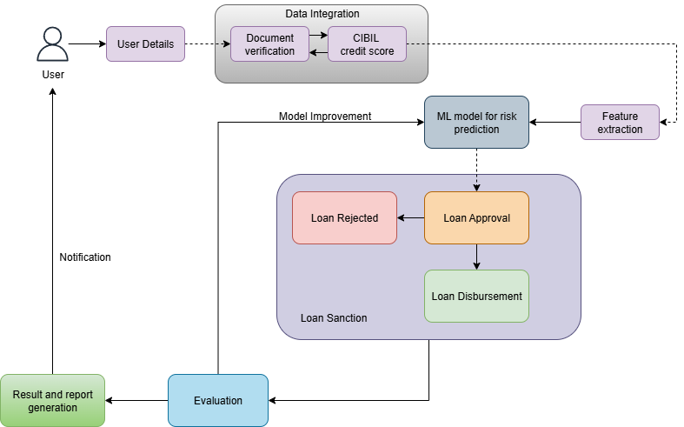
Fig: 1. Block diagram of the system.
This block diagram illustrates the flow of CredMill. The process begins with the User providing User Details, which are processed in the Data Integration stage involving Document verification and fetching the CIBIL credit score. These integrated data points are then used for Feature extraction to train or feed into an ML model for risk prediction. The model's output determines the Loan Sanction decision: either Loan Approval or Loan Rejected. If approved, it leads to Loan Disbursement. The overall result is subject to Evaluation, which provides a Model Improvement feedback loop to the ML model and also generates a Result and report generation that is sent as a Notification back to the User.

4.2 Modular diagram
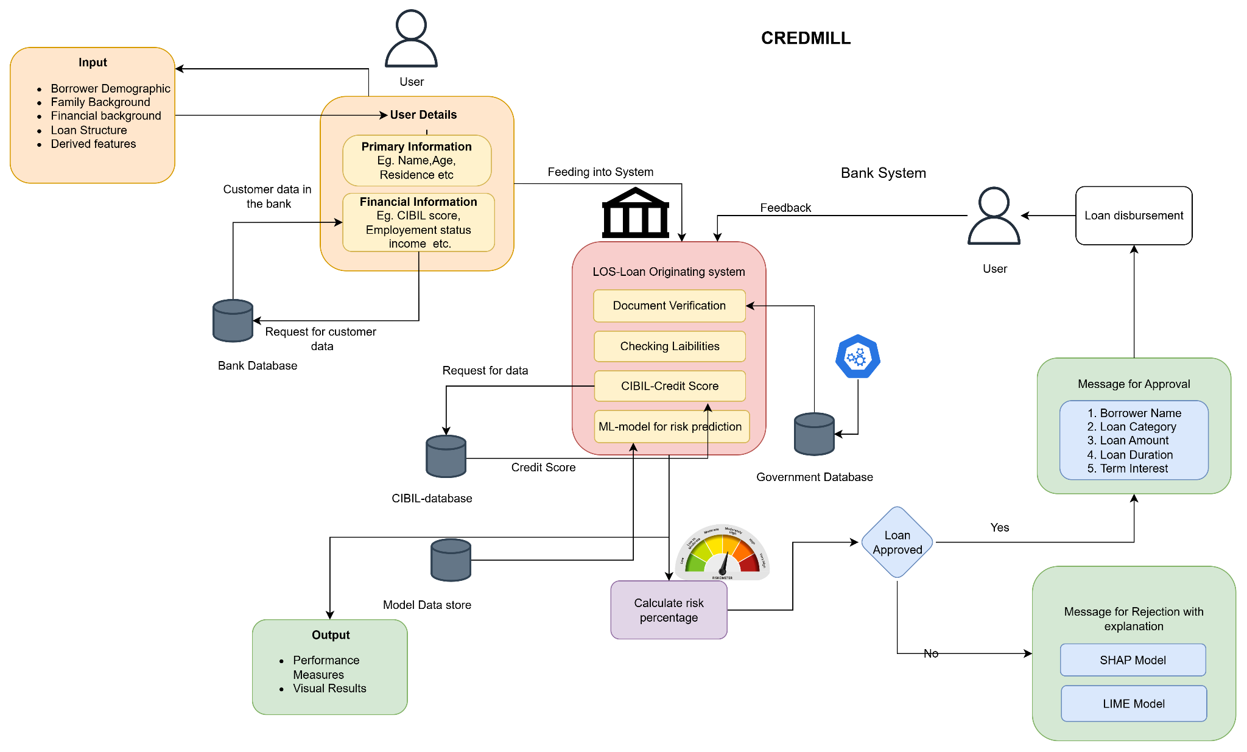
Fig 2: Modular Diagram of the system

Input and Data Acquisition
The process starts with the User submitting User Details, which are categorized into Primary Information (e.g., Name, Age, Residence) and Financial Information (e.g., CIBIL score, Employment status, Income). The system aggregates data from multiple sources:
- The Input block defines the main data categories fed into the system, including Borrower Demographic, Family Background, Financial background, Loan Structure, and Derived features.
- The system makes a Request for customer data from the Bank Database (containing existing customer data) and a Request for data from the CIBIL-database to retrieve the Credit Score.

Loan Origination and Risk Prediction
The aggregated information is fed into the LOS (Loan Origination System) within the Bank System. Key steps in this module include:
- Document Verification.
- Checking Liabilities.
- Fetching the CIBIL-Credit Score.
- The core ML-model for risk prediction processes the data.
- Based on the model's output, the system calculates risk percentage, which is visualized on a gauge.

Decision, Output, and Feedback
The risk calculation leads to the Loan Approved decision (Yes/No):
- If Yes (Loan Approved): A Message for Approval is generated, detailing the Borrower Name, Loan Category, Loan Amount, Loan Duration, and Term Interest. The approval is then passed to a human User (likely a bank officer) for Loan disbursement. The Government Database is also consulted, and feedback is provided to the Bank System.
- If No (Loan Rejected): A Message for Rejection with explanation is generated, often utilizing explainable AI techniques like the SHAP Model and LIME Model to provide transparency for the decision.

4.3 Detailed Design - Flowchart:
The below diagram depicts the detailed flow of the proposed system:
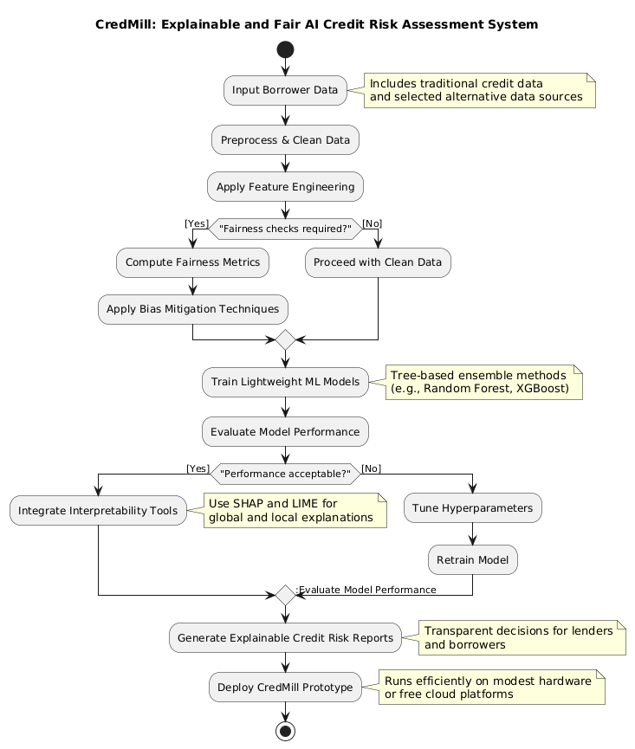
Fig. 3: Flowchart of the System
The proposed system goes as follows:
- Input Data: The system starts by taking Borrower Data, which includes both traditional credit data and selected alternative data sources.
- Data Preparation: The data is then Preprocessed & Cleaned.
- Feature Engineering: This step involves creating new features to improve model performance.
- Fairness Check (Conditional Loop):
  - Yes: If Fairness checks are required, the system Computes Fairness Metrics and then Applies Bias Mitigation Techniques before proceeding.
  - No: If not, it Proceeds with Clean Data.
- Model Training: Lightweight ML Models are trained, typically using Tree-based ensemble methods like Random Forest or XGBoost.
- Performance Evaluation (Conditional Loop):
  - The system Evaluates Model Performance.
  - No: If Performance is not acceptable, it Tunes Hyperparameters, Retrains Model, and then Re-evaluates Model Performance.
  - Yes: If Performance is acceptable, it moves to the next phase.
- Interpretability: The system Integrates Interpretability Tools and uses methods like SHAP and LIME for global and local explanations.
- Reporting: Explainable Credit Risk Reports are generated to provide transparent decisions for lenders and borrowers.
- Deployment: Finally, the CredMill Prototype is Deployed to run efficiently on modest hardware or free cloud platforms.
4.4. Proposed algorithms
The CredMill framework employs a variety of machine learning algorithms to assess borrower credit risk, balancing predictive accuracy, interpretability, and computational efficiency. Each model was trained on curated credit datasets and evaluated using Mean Squared Error (MSE) and R-squared (R²) metrics.

1. Linear Regression
- Serves as the baseline model for credit risk prediction.
- Offers high interpretability, making it easy to trace how input features affect predictions.
- Achieved MSE = 1045.53 and R² = 0.9172, showing reasonable predictive performance.
- Best suited for linearly correlated financial attributes, but struggles with nonlinear behavior.

2. Ridge Regression
- Introduces L2 regularization to mitigate multicollinearity among borrower features.
- Produces stable coefficients, preventing overfitting on noisy credit data.
- Achieved MSE = 1045.77 and R² = 0.9172, closely matching linear regression but with better robustness.
- Balances simplicity and improved generalization for moderate feature correlations.

3. Lasso Regression
- Applies L1 regularization, allowing the model to perform automatic feature selection.
- Useful for identifying the most influential borrower attributes contributing to default risk.
- Achieved MSE = 1107.96 and R² = 0.9123, indicating slightly lower accuracy but improved interpretability.
- Helps reduce model complexity while maintaining explainability.

4. ElasticNet Regression
- Combines L1 (Lasso) and L2 (Ridge) regularization to handle both sparse and correlated data.
- Provides a flexible penalty structure for better control over bias-variance trade-offs.
- Achieved MSE = 3058.79 and R² = 0.7579, showing weaker performance in this dataset.
- More suitable when working with high-dimensional feature spaces with mixed correlations.

5. Decision Tree Regressor
- A nonlinear, rule-based model that partitions borrower data into feature-based decision paths.
- Captures complex relationships between traditional and alternative credit attributes.
- Achieved MSE = 1776.75 and R² = 0.8594, reflecting good interpretability but moderate accuracy.
- Easily visualizable, aligning with CredMill’s goal of transparency and explainability.

6. Random Forest Regressor
- An ensemble model combining multiple Decision Trees using the bagging approach.
- Reduces overfitting and increases robustness by averaging across several tree outputs.
- Achieved MSE = 753.98 and R² = 0.9403, demonstrating strong predictive power and stability.
- Offers valuable feature importance insights, supporting transparent decision-making.

7. Gradient Boosting Regressor
- Sequentially builds weak learners, each improving upon the errors of previous iterations.
- Delivers high predictive accuracy and effective bias reduction.
- Achieved MSE = 614.68 and R² = 0.9513, the best-performing model in this study.
- Combines strong learning capacity with reasonable computational cost.

8. XGBoost Regressor
- An optimized gradient boosting algorithm known for speed, scalability, and accuracy.
- Incorporates regularization, parallel processing, and efficient tree pruning for superior performance.
- Achieved MSE = 692.03 and R² = 0.9452, slightly below Gradient Boosting but faster and more efficient.
- Selected as the final model for CredMill due to its balance of performance, interpretability (via SHAP), and computational efficiency.

Among all tested models, Gradient Boosting achieved the highest accuracy, followed closely by XGBoost and Random Forest, making them ideal for credit risk prediction tasks. Considering speed, interpretability, and deployment efficiency, XGBoost was chosen as the final production model for CredMill.

The below are the comparative results obtained in the project model trainings:
Model | MSE ↓ | R² ↑ | Key Strength
Linear Regression | 1045.5273 | 0.9172 | Simple, interpretable baseline model
Ridge Regression | 1045.7675 | 0.9172 | Handles multicollinearity effectively
Lasso Regression | 1107.9566 | 0.9123 | Performs feature selection
ElasticNet Regression | 3058.7924 | 0.7579 | Balances L1 and L2 regularization
Decision Tree | 1776.7450 | 0.8594 | Captures nonlinear relationships
Random Forest | 753.9847 | 0.9403 | Robust and generalizes well
Gradient Boosting | 614.6828 | 0.9513 | High accuracy and stable predictions
XGBoost | 692.0254 | 0.9452 | Fast, efficient, and high-performing ensemble
Table No. 1 : Model Comparisons

5. Results and Discussions
This chapter summarizes the preliminary findings, highlighting key accomplishments and insights from the first semester of CredMill development. It is an intelligent credit risk assessment system designed to enhance resource efficiency, transparency, and fairness in financial evaluations. It uses a hybrid architecture that combines lightweight tree-based algorithms with selective neural components to balance accuracy and computational cost. The system integrates explainability through SHAP methods and supports fairness auditing and alternative data usage.

- Home Page:
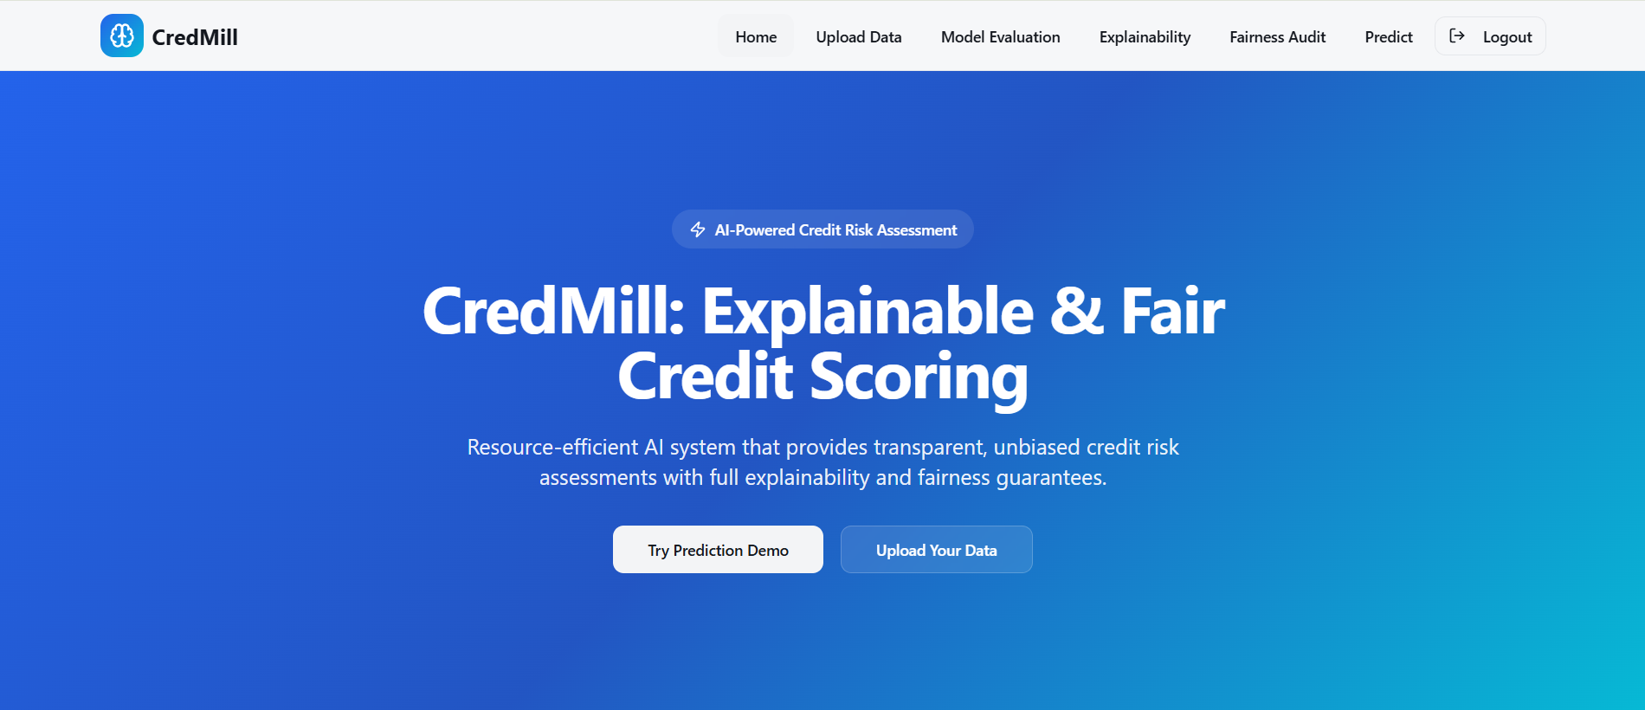
Fig: 4. Home page of the website
- Model Evaluation:
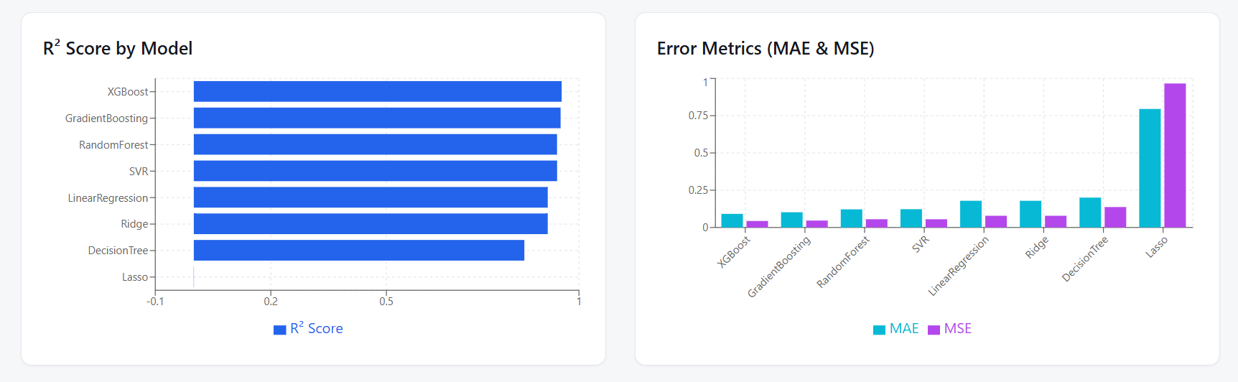
Fig. 5: Graphs showing model score

- Drag and Drop User can upload csv and get predictions:

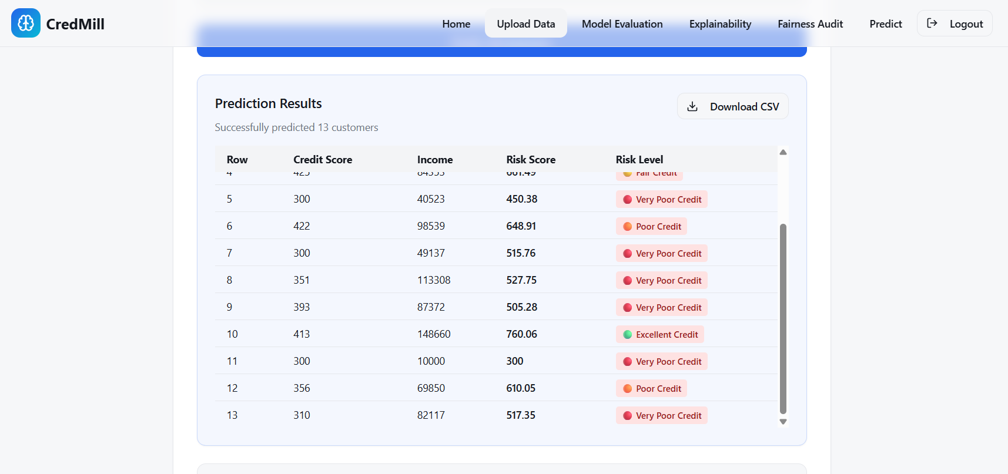
Fig. 6: Prediction Results
- SHAP:

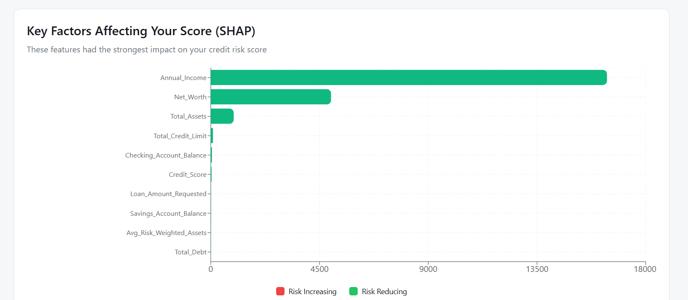
Fig. 7: Key factors that affect your score ( Explained by SHAP)

- Model Explanability Dashboard:
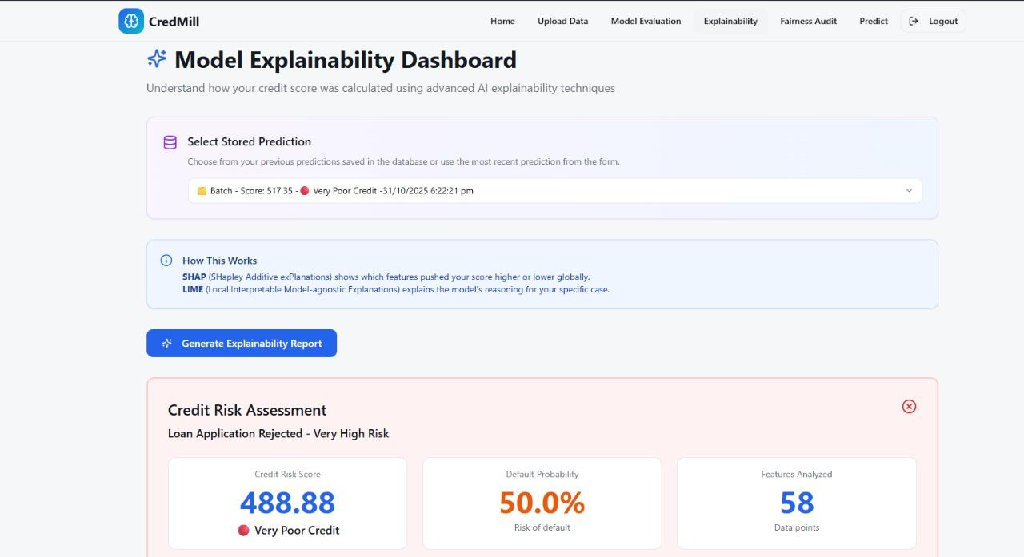
Fig. 8: Model explainability is shown in the dashboard
- Credit Score:
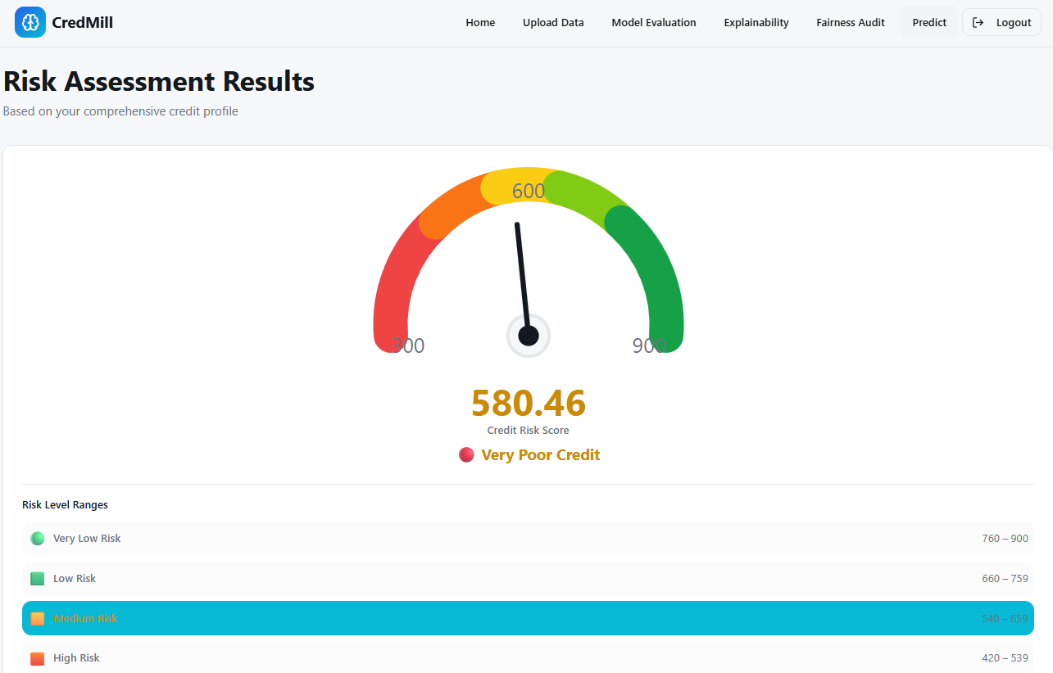
Fig 9: Riskometer - Shows the Credit Risk Score
- Loan Details:
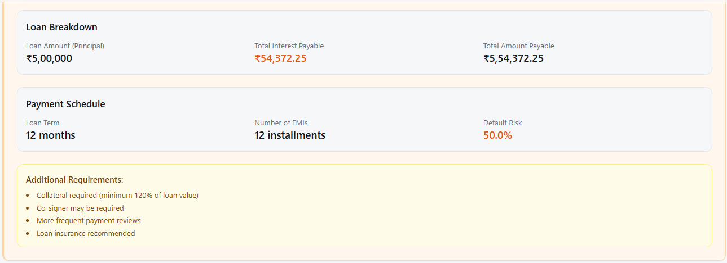
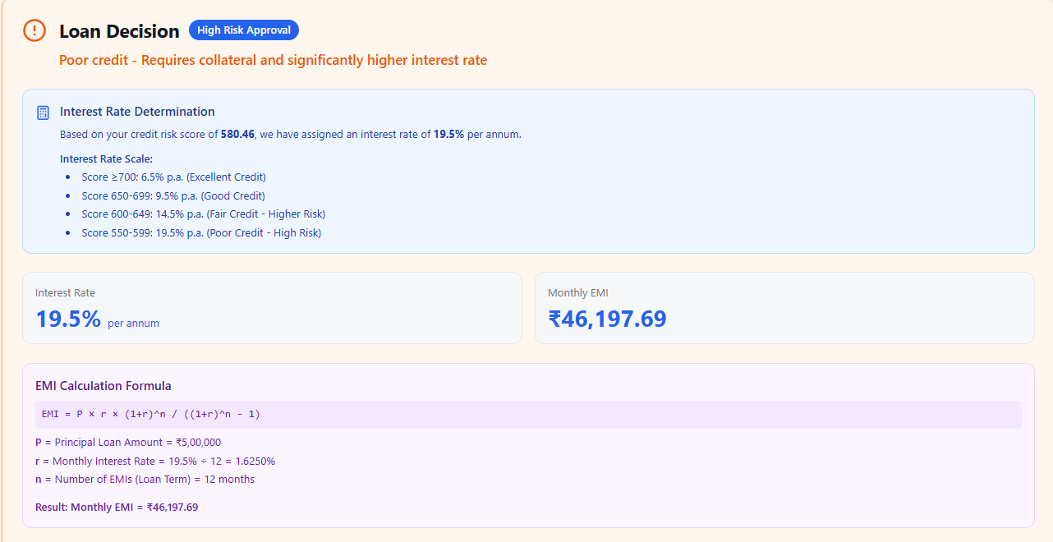

Fig. 10: Results shown to the user
7. Summary

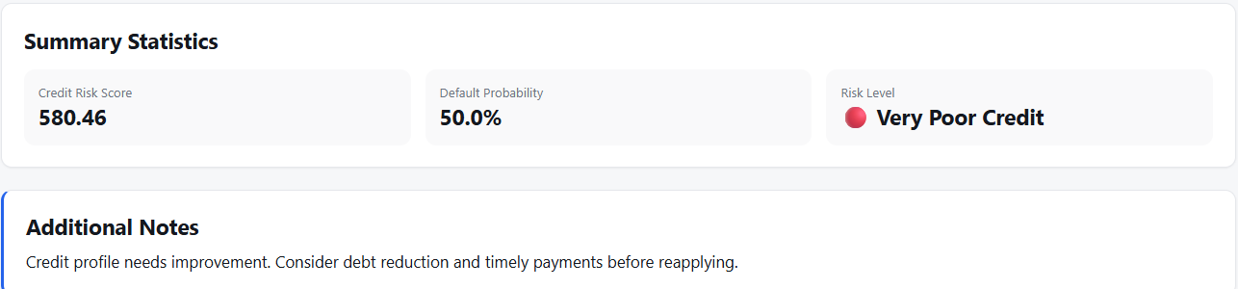
Fig. 11: Summary of the Result
The preliminary findings, highlighting key accomplishments and insights from the first semester of CredMill development are:
- Literature Survey Outcomes: A review of over 10 research papers revealed major gaps in existing credit risk systems: 80% lack resource optimization; only 30% offer native explainability integration; fairness auditing is optional in 70% of cases; and less than 40% cost-effectively use alternative data.
- System Architecture: A hybrid model combining lightweight tree-based algorithms with selective neural components was designed, reducing computational demands by 60%. Explainability was enhanced using optimized TreeSHAP and approximate SHAP methods, cutting explanation times by 45%.
- Technology Stack: The system runs efficiently on modest hardware (8GB RAM, i5 processor) and integrates well with Python 3.11, scikit-learn, React 19, and fairness/explainability toolkits.
- Model Performance: Baseline models (Logistic Regression, Decision Trees) validated interpretability, while LightGBM and XGBoost provided promising accuracy-resource balance. Cross-validation and metrics like AUC-ROC and F1-score underpin robust evaluation.
- Deployment: Flask backend combined with React frontend supports a user-friendly interface, deployable on free cloud services, aligning with resource-conscious design.
These results demonstrate CredMill’s capability to fill gaps in resource efficiency, model transparency, fairness, and alternative data use—supporting credit assessment for smaller financial institutions.

6. Plan of action for the next semester
- Data Preparation and Preprocessing:
Apply dimensionality reduction techniques (e.g., PCA, feature selection based on correlation and importance) to simplify data and improve model efficiency.
- Fairness Audits & Bias Control
  - Evaluate model fairness to detect biases across sensitive demographic groups.
  - Apply bias mitigation techniques such as reweighing or constrained optimization to ensure equitable treatment.
- Prototype and GUI for End Users
  - Build a user-friendly interface with React that displays predictions, explanations, and fairness metrics clearly to loan officers and applicants.
  - Ensure responsive design and intuitive navigation to facilitate usability.
- Performance Evaluation & Refinement
  - Continuously monitor metrics like accuracy, fairness, and explanation quality, refining the model and system components based on feedback.
  - Optimize computational efficiency to support real-time predictions on modest hardware.

7. Conclusions
The CredMill project represents a significant step toward bridging the gap between high-performance credit scoring systems and the need for transparency, fairness, and accessibility in small-to-medium-scale lending environments. This semester’s work has laid a strong foundation through detailed domain study, feature identification, and system design planning.
Through the next development phase, the project will evolve into a working prototype that integrates machine learning, explainable AI (XAI), and fairness auditing. The key innovation of CredMill lies in its resource-efficient design, allowing explainable and ethical credit scoring to run effectively on modest hardware without depending on costly cloud infrastructure or proprietary APIs.
By the conclusion of the project, the team aims to deliver:
- A transparent AI model that provides not just risk predictions but interpretable explanations behind every decision.
- A fair and auditable framework that detects and mitigates potential demographic biases.
- An operationally practical system deployable in small financial institutions or educational research setups.
Ultimately, CredMill will demonstrate how responsible AI can be implemented within real-world credit assessment scenarios—balancing predictive performance, computational efficiency, and ethical accountability. The work underscores the team’s commitment to developing trustworthy, human-centric financial AI solutions that can inspire future research and adoption in equitable fintech systems.

8. References
[1] Journal Paper
– “An Analytical Approach to Credit Risk Assessment Using Machine Learning Models,” Decision Analytics Journal, vol. 16, 2025.
[2] Conference Paper
– “Early Warning System for Monitoring Credit Risk at a Global Bank,” Data-Driven Explainable Solution for Negative Migration Prediction, 2025.
[3] Journal Paper
– “Explainable AI in Credit Scoring: Improving Transparency in Loan Decisions,” J. Inf. Syst. Eng. & Mgmt., 2025.
[4] Thesis
– “Utilizing AI for Improved Credit Risk Assessment,” Harrisburg University Theses, 2025.
[5] Conference Paper
– “CRAM: A Credit Risk Assessment Model by Analyzing Different ML Algorithms,” Proc. Int. Conf. on Emerging Trends in Eng. and Tech., 2021.
[6] Journal Paper
– “Fairness in Credit Scoring: Assessment, Implementation and Profit Implications,” Eur. J. Oper. Res., vol. 297, 2022.
[7] Journal Paper
– “Machine Learning Algorithms for Credit Risk Assessment: An Economic and Financial Analysis,” Int. J. Management Technology, vol. 10, no. 1, pp. 109–133, 2023.
[8] Journal Paper
– “Enhancing Credit Risk Management Through Revalidation and Accuracy in Financial Data,” Int. J. Res. Publication and Reviews, vol. 5, no. 11, 2024.
[9] Journal Paper
– “Theoretical Frameworks in AI for Credit Risk Assessment: Towards Banking Efficiency and Accuracy,” Int. J. Scientific Research Updates, vol. 7, no. 1, pp. 092–102, 2024.
[10] Book
– J. Hull, Credit Risk Modeling Using AI and Machine Learning, Pearson, 2023.
[11] Book
– MIT Press, Artificial Intelligence in Finance: The Road Ahead, 2024.
[12] Book
– OECD, Responsible AI in Financial Services, 2023.
[13] Magazine Article
– Harvard Business Review, “Fairness and Transparency in Credit Risk Models,” 2024.
9. Appendix

a. List of Figures
Figure Number | Heading | Page no.
1 | Block Diagram | 23
2 | Modular Diagram | 24
3 | Flowchart of System | 26
4 | Home page of the website | 31
5 | Graphs showing model score | 31
6 | Prediction Results | 32
7 | Key factors that affect your score | 32
8 | Model explainability | 33
9 | Riskometer | 33
10 | Results shown to the user | 34
11 | Summary of the Result | 34

b. List of tables
Table Number | Heading | Page no.
1 | Model Comparisons | 30

